1)Consider the set of 4 processes whose arrival time and burst time are given below-

| **Process No.** | **Arrival Time** | **Burst Time** |
| --- | --- | --- |
|  |
| **P1** | 0 | 3 |
| **P2** | 0 | 2 |
| **P3** | 2 | 1 |
| **P4** | 5 | 2 |

If the CPU scheduling policy is Shortest Remaining Time First, calculate the average waiting time and average turn around time.

2)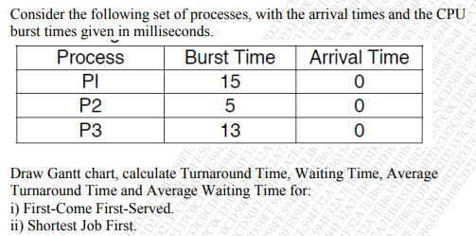3)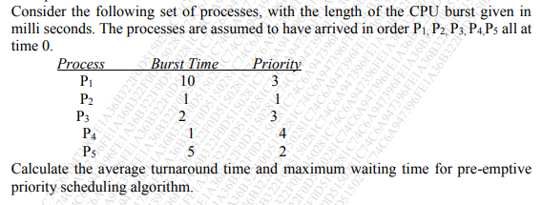

4)